Project 1

Cluster planning –Two Node Cluster
nn.cluster.com

Namenode Datanode Tasktracker

snn.cluster.com

Secondary Namenode Jobtracker Datanode Tasktracker

nn.cluster.com
/etc/sysconfig/network-script/ifcfg-eth0
DEVICE="eth0"
IPADDR=192.168.23.154
NETMASK=255.255.255.0
DNS=192.168.23.2
NM_CONTROLLED="yes”
/etc/sysconfig/network
NETWORKING=yes
HOSTNAME=nn.cluster.com
GATEWAY=192.168.23.2
/etc/hosts
192.168.23.154 nn.cluster.com nn
192.168.23.155 snn.cluster.com snn

Snn.cluster.com
/etc/sysconfig/network-script/ifcfg-eth0
DEVICE="eth0"
IPADDR=192.168.23.155
NETMASK=255.255.255.0
DNS=192.168.23.2
NM_CONTROLLED="yes”
/etc/sysconfig/network
NETWORKING=yes
HOSTNAME=nn.cluster.com
GATEWAY=192.168.23.2
/etc/hosts
192.168.23.154 nn.cluster.com nn
192.168.23.155 snn.cluster.com dn

Make sure that these following Configuration and commands are executed in the hadoop cluster
Vi /etc/selinux/config
SELINUX=disabled
Service iptables stop
Chkconfig iptables off
Service ip6tables stop
Chkconfigip6tables off
Configuration
The default HDFS block size should be 128 MB-hdfs-site.xml
<property>
<name>dfs.block.size</name>
<value>134217728</value>
</property>

The default Secondary Namenode Snapshot interval should be 3 hours –core-site.xml

<property>
<name>fs.checkpoint.period</name>
<value>10800</value>
</property>

All the Hadoop log files be stored in /log folder in user’s home folder-hadoop-env.sh

export HADOOP_LOG_DIR=/home/hadoop

All the files, which get deleted from HDFS, should be recycled in to Trash Directory with a time interval of 160 minutes-core-site.xml
<Property>
<name>fs.trash.interval</name>
<Value>160</value>
</property>

The user should not be able to upload more than 500 files to the cluster, at any given point of time. –fair-scheduler.xml
<allocations>
<user name=”hadoop”>
<maxRunningjobs>500</maxRunningJobs>
</user>
</allocations>

Screen shots of two nodes that working perfect : -

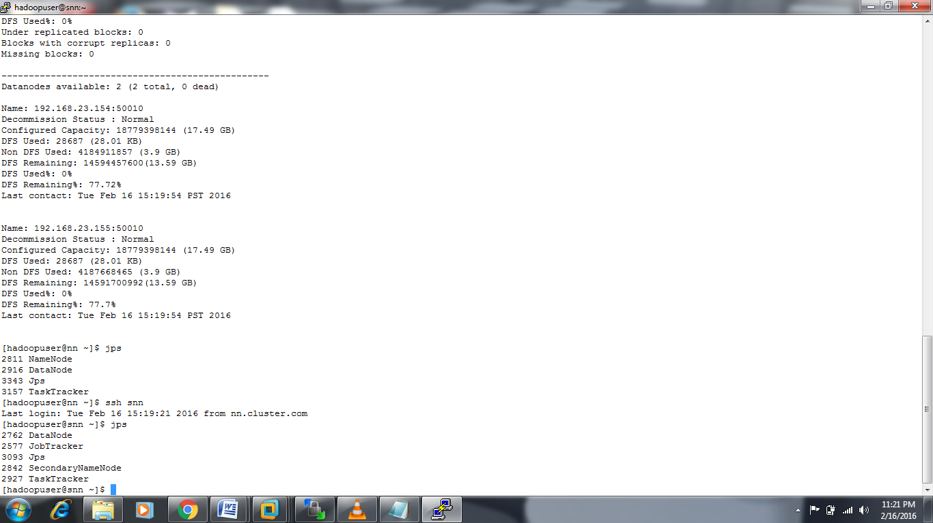

The cluster must have Rack Awareness configured with each Datanode falling in to separate racks – Core-site.xml

<property>
<name>topology.script.file.name</name>
<value>/home/hadoopuser/hadoop/topology.sh</value>
</property>

/home/hadoopuser/topology.data
192.168.23.154 /rack1
192.168.23.155 /rack2
/home/hadoopuser HADOOP_CONF=/home/hadoopuser/hadoop

while [ $# -gt 0 ] ; do
nodeArg=$1
exec< ${HADOOP_CONF}/topology.data
result=""
while read line ; do
ar=( $line )
if [ "${ar[0]}" = "$nodeArg" ] ; then
result="${ar[1]}"
fi
done
shift
if [ -z "$result" ] ; then
echo -n "/default/rack "
else
echo -n "$result "
fi
done/hadoop/topology.sh

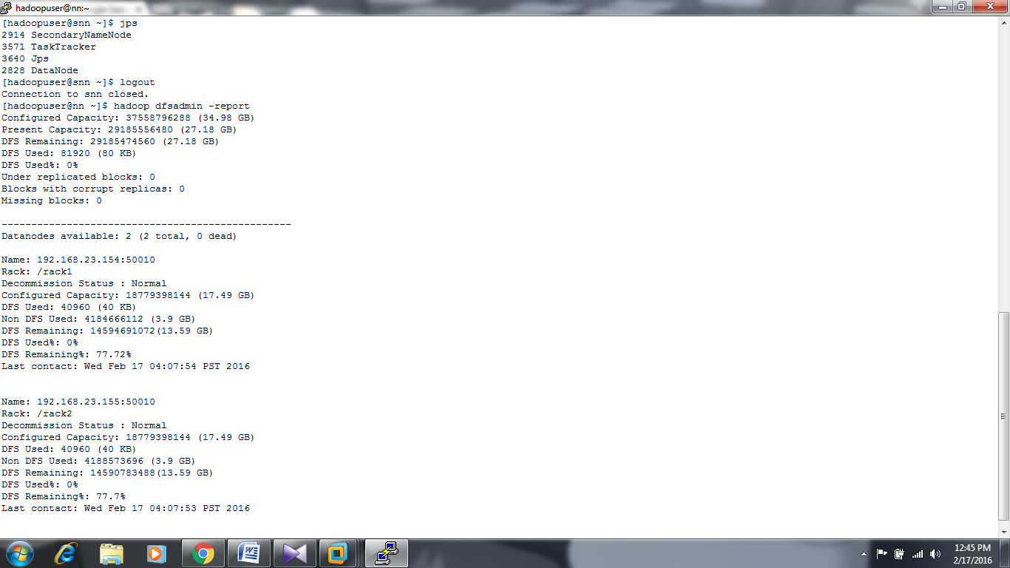

Once completed, pen down the step by step process to upgrade this cluster from Hadoop 1.2.1 to Hadoop 2.6.0
Steps to upgrade:

1. Stop all the currently running jobs and stop-mapred.sh to stop mapreduce processes.
2. Take the backup of metadata with following commands:

a. mkdir backup
b. hadoop fsck / -blocks -files -locations -racks > backup/fsck.log
c. hadoop fs -lsr / > backup/lsr.log
d. hadoop dfsadmin -report > backup/dfsadmin.log
e. cp -rv data/nn backup/

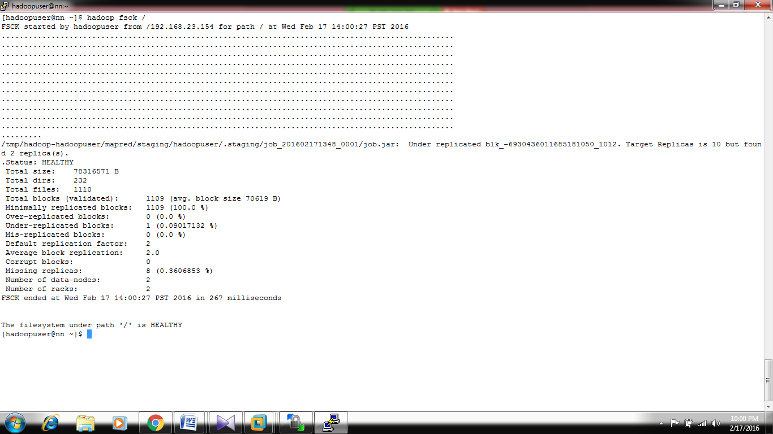



3. (Optional) - Take the backup of the HDFS data.

4. stop-dfs.sh - this will stop all the processes in the cluster.

5. Install hadoop version 2.
a. in version 2: same properties in core-site.xml/hdfs-site.xml/slaves/hadoop-env.sh need to be added with the foll. exceptions:
b. fs.default.name becomes - fs.defaultFS
c. dfs.name.dir becomes dfs.namenode.name.dir
d. dfs.data.dir becomes dfs.datanode.data.dir
e. no masters file for the snn, instead of that add the following property in hdfs-site.xml in NN.
dfs.namenode.secondary.http-addres = <ip of snn>:50090
dfs.namenode.checkpoint.dir = <snn checkpoint dir>
f. Slaves and hadoop-env.sh files will remain same
g. Also, change the .bash_profile file accordingly.

Hadoop2/etc/hadoop/core-site.xml
<configuration>
<property>
<name>fs.defaultFS</name>
<value>hdfs://192.168.23.154:8020</value>
</property>

Hadoop2/etc/hadoop/hdfs-site.xml
<configuration>
<property>
<name>dfs.namenode.name.dir</name>
<value>/home/hadoopuser/data/nn</value>
</property>
<property>
<name>dfs.datanode.data.dir</name>
<value>/home/hadoop/data/dn</value>
</property>
<property>
<name>dfs.namenode.checkpoint.dir</name>
<value>/home/hadoopuser/data/snn</value>
</property>
<property>
<name>dfs.replication</name>
<value>2</value>
</property>
<property>
<name>dfs.block.size</name>
<value>134217728</value>
</property>
<property>
<name>dfs.namenode.secondary.http-address</name>
<value>192.168.23.155:50090</value>
</property>
</configuration>

Note: We are not adding anything for the mapreduce as it is a newer feature in HADOOP 2.

6. Upgrade the namenode with the following command:

hadoop-daemon.sh start namenode -ugprade

start the datanode and secondary namenode with the following commands:
hadoop-daemon.sh start datanode
hadoop-daemon.sh start secondarynamenode

7. If there are any issues in the upgrade, follwing steps needs to be used to rollback:
a. stop-dfs.sh
b. remove the nn metadata directory.
c. copy the old nn metadata directory to the same location.
d. start-dfs.sh

8. Finalize the upgrade, if everthing is successful.
hdfs dfsadmin -finalizeUpgrade

Note: you won't be able to rollback after this command.

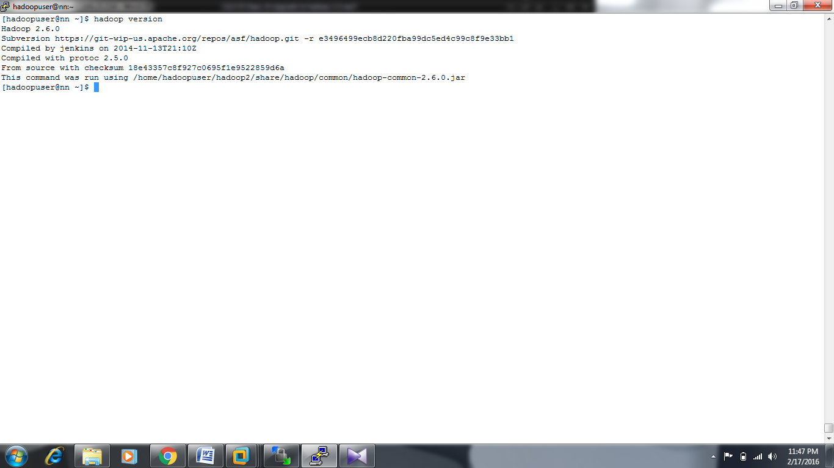

Layout a plan to expand this cluster to accommodate 50 TB of data. The plan should include options to add nodes seamlessly, without formatting. Consider a MOM growth of 20 TB for the cluster. List out the sample configurations for Datanodes as well.

Initial Data is of 50 TB.
Let us assume Hard disk =4TB
Intermediate Map reduce data 25%
Non HDFS reserved space per disk 30%
Dedicated space=HDD size*(1-Non HDFS reserved space per disk /100+Intermediate Map reduce data /100)
=(4*1-(o.25+0.30))=1.8TB(which is node capacity)
So initially we need = 50TB/1.8 TB=28 nodes
Each month increase of 20 TB.
so each month we need to add 20 TB /1.8 TB=12 nodes.
So for a year =1st month 50 TB + 11 month(220 TB) =28 nodes + 11*12(132 nodes)
Totally we require 160 nodes.

